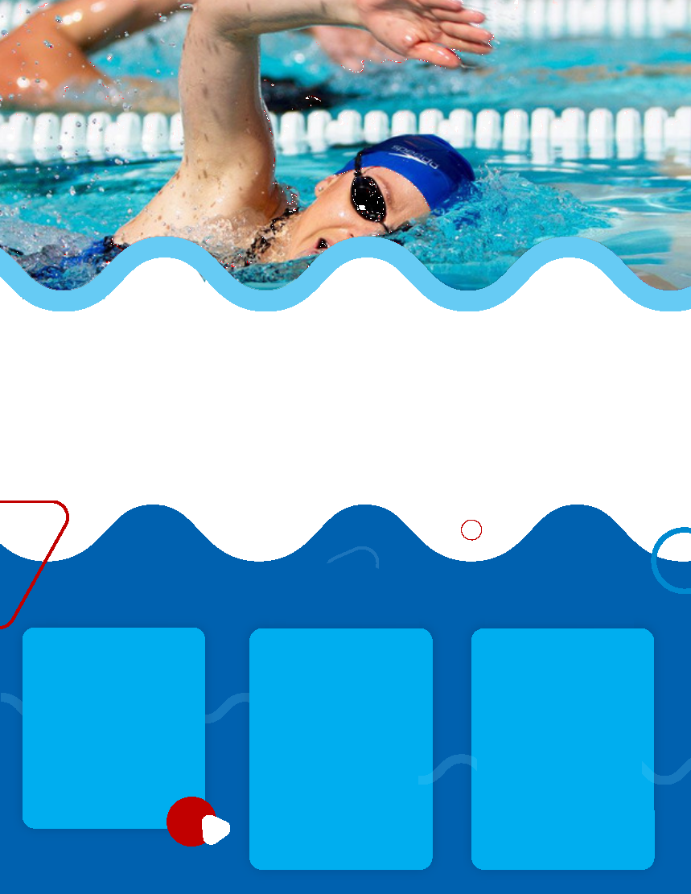

WHO

**Lessons will be available for any student-athlete, coach, faculty or staff can’t swim.**

HOW

**Lessons are extremely limited. To sign up, contact:**

**Contact Name**

**(222) 555-1212**

**email@address.edu**

WHAT

**Each year 6-8 college athletes drown.**

**In April the _________ University team will be offering free lessons**

**LEARN TO SWIM**

**FROM THE BEST SWIMMERS ON CAMPUS**